**GUIDELINES ON HOW TO PUT YOUR BRIEF TOGETHER**

- Please ensure you submit your completed briefing document to your designer within 3 days of project activation.
- Your Corporate Identity is the face of your Business for the years to come. When completing your brief, make sure choose options that are timeless and you will be happy with for atleast five years.
- Please ensure that you complete this briefing document as accurately as possible, the more in depth the brief the more we can assist you. Please ensure you do a thorough spelling check (if applicable).
- Please take note of the time-line for each package. These are detailed below. Your timeline starts from the date of activation.
- If you require any assistance with this document then please speak with our friendly sales consultant or your designer.
- Once a project has been activated, your Project Manager will also assist you with any queries you have during development.
- The complete scope of your product will have been detailed in quote and related invoice. This is a standard briefing document.
- Legal compliance. You need to follow all Copywrite laws. We cannot directly copy an image that you like. If there is a specific image that you want – please provide this as a High Resolution file created as a vector. Please also attached the ownership licence for this image which details that it can be used for commercial purposes and can be used as a Logo.
- If you have bought a website package in combination to your Corporate Identity package – we will activate your website development one week after your Corporate Identity package. This avoids delays with your website should your logo not be complete in time. Your logo also essentially dictates your websites colour pallet, look and feel.

•••

STEP ONE: Your Package

To ensure you are completing the information for the correct package – please highlight the one you purchased (this information can be found on your invoice):

CORPORATE IDENTITY THREE: ELEMENTAL  - Logo Design (.jpg), Business Card Design (.pdf), Letterhead Design (.doc) & Email Signature Design (.doc).  - Stock based Logo. Three colours (including black & white) and one shadow.  - Up to 3 concepts, with 2 reviews of each.  - 21 Day time-line. 11,5 Development hours. |  | CORPORATE IDENTITY THREE: CUSTOM  - Logo Design (.jpg), Business Card Design (.pdf), Letterhead Design (.doc) & Email Signature Design (.doc).  - Digitally hand drawn Logo. Three colours (including black & white) and one shadow.  - Up to 3 concepts, with 2 reviews of each.  - 21 Day time-line. 13,5 Development hours.
CORPORATE IDENTITY FIVE: ELEMENTAL  - Logo Design (.jpg), Business Card Design (.pdf), Letterhead Design (.doc) & Email Signature Design (.doc).  - Stock based Logo. Five colours (including black & white) and one shadow.  - Up to 3 concepts, with 2 reviews of each.  - 21 Day time-line. 14 Development hours. |  | CORPORATE IDENTITY FIVE: CUSTOM  - Logo Design (.jpg), Business Card Design (.pdf), Letterhead Design (.doc) & Email Signature Design (.doc).  - Digitally hand drawn Logo. Five colours (including black & white) and one shadow.  - Up to 3 concepts, with 2 reviews of each.  - 21 Day time-line. 16 Development hours.
CORPORATE IDENTITY SEVEN: ELEMENTAL  - Logo Design (.jpg), Business Card Design (.pdf), Letterhead Design (.doc) & Email Signature Design (.doc).  - Stock based Logo. Full Colour and one shadow.  - Up to 3 concepts, with 2 reviews of each.  - 21 Day time-line. 17,5 Development hours. |  | CORPORATE IDENTITY SEVEN: CUSTOM  - Logo Design (.jpg), Business Card Design (.pdf), Letterhead Design (.doc) & Email Signature Design (.doc).  - Digitally hand drawn Logo. Full Colour and one shadow.  - Up to 3 concepts, with 2 reviews of each.  - 21 Day time-line. 19,5 Development hours.

For each component of your package (i.e. Logo, Letterhead, etc) your designer will give you three options for your first review. You can then pick the elements you prefer of each, as well as the colour pallet you would prefer. From there they will create three more options for your second review, from which you will then chose the one you like.

•••

STEP TWO: Your Business

Please give us a little more information about your business and what you do. If your company has a Motto or Mission statement, please also include this below:

Business Name | :
What your business does | :
What sector is your business in? | :
Your businesses Motto | :
Your businesses Mission Statement | :
Is your business service or product orientated? | :
Other Comments | :

•••

STEP THREE: Fonts & Colour Pallets

Have you considered your colour scheme and Look & Feel? A good reference for a Colour Scheme can be found at https://colorhunt.co/. Font options can be viewed at https://fonts.google.com/. Alternatively you can include a link to a website with the look and feel that you like.

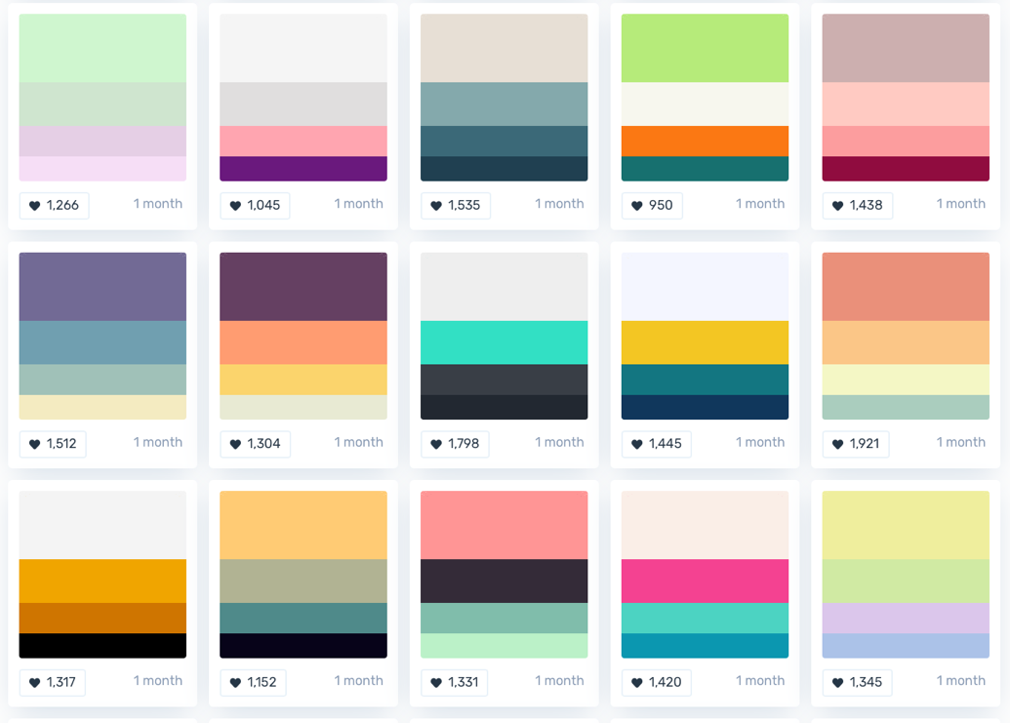
** Examples only

Please give us two colour pallet options and three font combinations below:

Colour Pallet 1  (Please remember that your colour options are dictated by the package you chose) | : | i.e. : #204051 , #3b6978 , #84a9ac , #e7dfd5  Or you can screenshot colour blocks of colour that you like.  Or a link www.websitedesign.co.za
Colour Pallet 2  (Please remember that your colour options are dictated by the package you chose) | :
Font 1  (Maximum 2 per combination) | : | i.e. : Courier & Dosis  Or a link www.websitedesign.co.za
Font 2  (Maximum 2 per combination) | :
Font 3  (Maximum 2 per combination) | :

•••

STEP FOUR: Your Logo

Do you want a Graphic based logo, or a Text based logo? Are there any specific types of images you would like to appear in your logo? Below are examples of each.

Text based Logo |  | Graphic based Logo
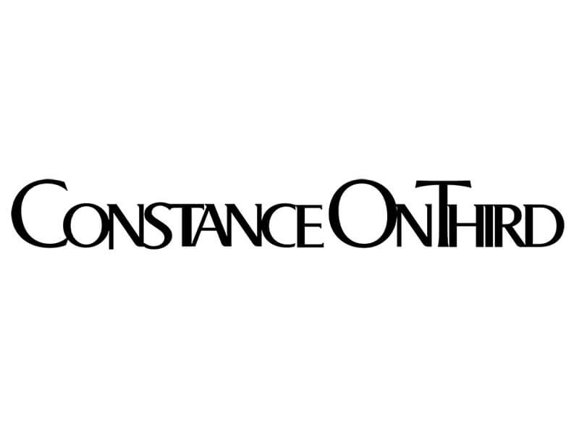 |  | 

Please include these options below:

Option 1  (Please remember that we cannot copy images) | : | i.e. : Text based
Option 2  (Please remember that we cannot copy images) | :
Option 3  (Please remember that we cannot copy images) | :
Example Image 1  (Please remember that we cannot copy images) | : | i.e. : 
Example Image 1  (Please remember that we cannot copy images) | :

•••

STEP FIVE: Your Business Card

If you meet clients face to face, your business card is usually your clients first impression of your business.

Your business card artwork will be designed as standard size 90 mm x 50 mm with a 5 mm bleed - All business cards must be cut to size when printed. We will provide you with business card artwork for up to 5 company members.

Please give us some information of what you would like:

Orientation  (Please remember that we cannot copy images) | : | i.e. : 1 portrait option and 2 landscape options
Single or double sided  (Please remember that we cannot copy images) | : | i.e. : 1 single sided option and 2 double sided options
Example 1  (Do you have an example of a card you like?) | : | 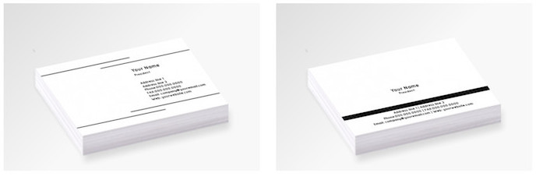
Example 2  (Do you have an example of a card you like?) | :
Example 3  (Do you have an example of a card you like?) | :

Please complete the fields below with your staff member details:

Member 1:
Name & Surname | :
Pre & Post-nominal letters | : | i.e. : “ BA PgDip MA” / “MRS” etc
Position | :
Mobile | :
Landline | :
Email | :
URL | :
Physical address | :
Social Media handles | :
** Other | :

Member 2:
Name & Surname | :
Post-nominal letters | :
Position | :
Mobile | :
Landline | :
Email | :
URL | :
Physical address | :
Social Media handles | :
** Other | :

Member 3:
Name & Surname | :
Post-nominal letters | :
Position | :
Mobile | :
Landline | :
Email | :
URL | :
Physical address | :
Social Media handles | :
** Other | :

Member 4:
Name & Surname | :
Post-nominal letters | :
Position | :
Mobile | :
Landline | :
Email | :
URL | :
Physical address | :
Social Media handles | :
** Other | :

Member 5:
Name & Surname | :
Post-nominal letters | :
Position | :
Mobile | :
Landline | :
Email | :
URL | :
Physical address | :
Social Media handles | :
** Other | :

•••

STEP SIX: Letterhead & Email Signature

Your Email signature usually mirrors your Letterhead. Is there any specific information you would like included on these? Do you have examples of what you like? Please give us some more information by completing the fields below. Please note – staff information completed in your business card section will be duplicated for your Letterhead and Email Signature.

Letterhead:
Special instruction | :
Special instruction | :
Special instruction | :
Examples  (These will be used as examples only and will not be duplicated) | : | 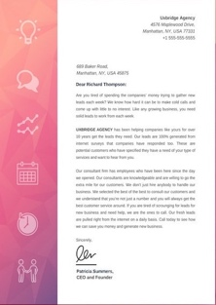  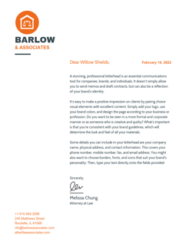  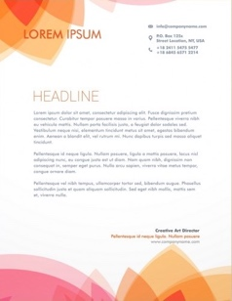

Email Signature:
Special instruction | :
Special instruction | :
Special instruction | :
Examples  (These will be used as examples only and will not be duplicated) | : | 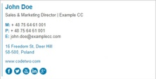  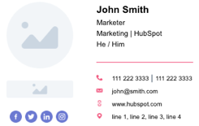  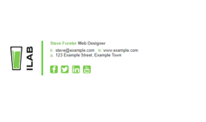

•••

CONGRATULATIONS!

If you have completed all of the above steps, then we have what we need in order to design a first preview of your Corporate Identity. To proceed, please send this document back to your sales consultant.

We look forward to creating the face of your Business.

•••

Disclaimer.
Websitedesign.co.za attempts to ensure the information within this document is correct at the time of publication. It reserves the right to update this document without written notice.

